Hindi Vidya Prachar Samiti’s
RAMNIRANJAN JHUNJHUNWALA COLLEGE OF ARTS, SCIENCE AND COMMERCE
(EMPOWERED AUTONOMOUS)

Mathematics for Data Science


Name: Surajkumar Yadav
Roll no: 10302
Class: MSc. Data Science and Artificial Intelligence Part I


Ramniranjan Jhunjhunwala College
of Arts, Science and Commerce

Department of Data Science and Artificial Intelligence

CERTIFICATE

This is to certify Surajkumar Yadav of MSc. Data Science and Artificial Intelligence Roll No. 10302 has successfully completed the practical of Mathematics for Data Science during the Academic Year 2024-2025.
Date :

(Prof. Rahul Yadav) External Examiner
Prof-In-Charge

INDEX
SR.NO | PRACTICAL NAME | DATE | SIGN
1 | Perform Data Collection, Cleaning, Modelling and Compilation | 19/09/2024
2 | Implementation of the Exploratory Data Visualization Technique | 16/09/2024
3 | Perform Different Statistics Distribution | 16/09/2024
4 | Implementation Hypothesis Testing | 31/08/2024
5 | Perform for Exploring Categorical and Binary Data | 19/09/2024
6 | Perform One and Two-way ANOVA on the given dataset. | 16/09/2024
7 | Implementation of Regression Analysis | 20/09/2024
8 | Perform Time Series Analysis | 20/09/2024
9 | Computing eigenvalues and eigenvectors for dimensionality reduction. | 28/08/2024
10 | Calculate the Maxima and Minima for the given function. | 04/09/2024
11 | Impute an example based on Rolle’s and Mean Value Theorem. | 04/09/2024
12 | Calculate the dot product of the vector and the norm of the vector. | 28/08/2024
13 | Impute Inverse of matrix by adjoint method. | 28/08/2024

Practical 1: Perform Data Collection, Cleaning, Modelling and Compilation
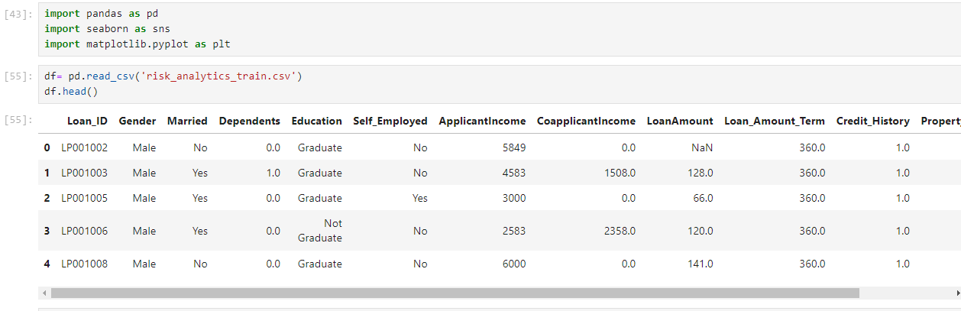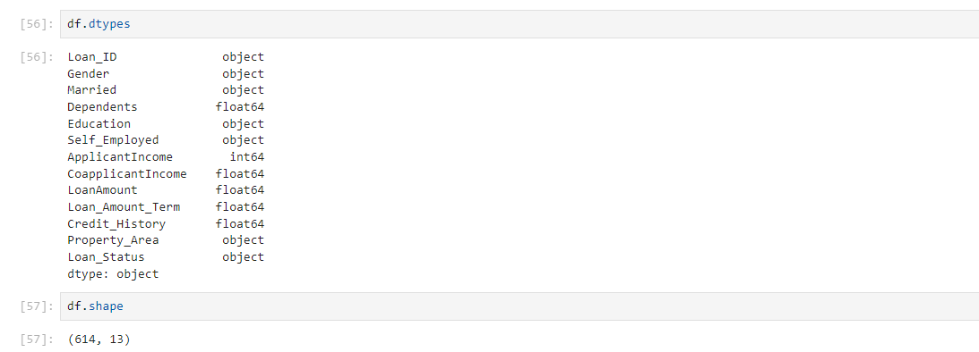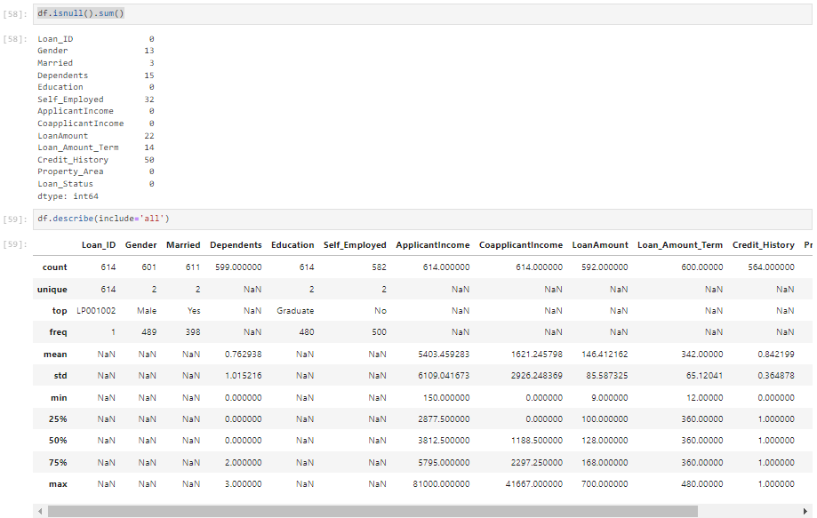
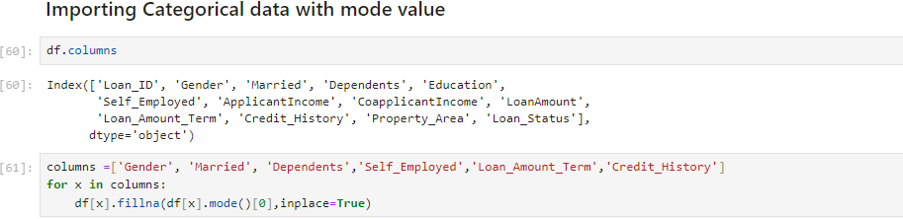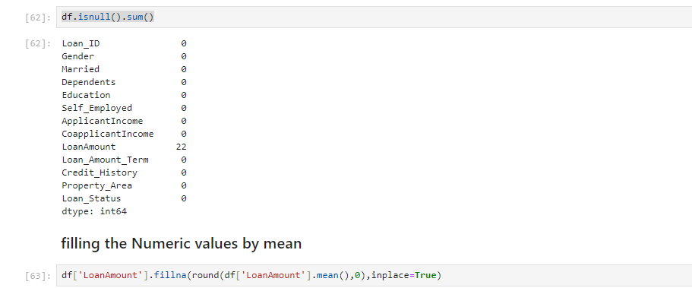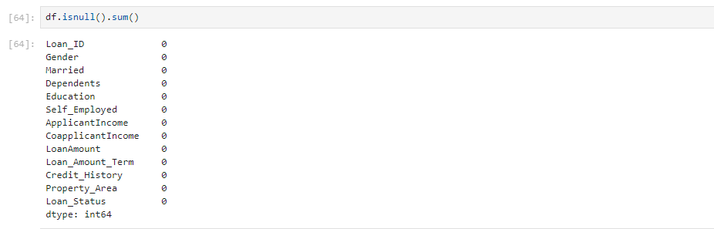

Practical 2: Implementation of the Exploratory Data Visualization Technique
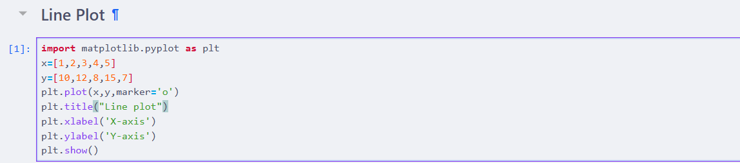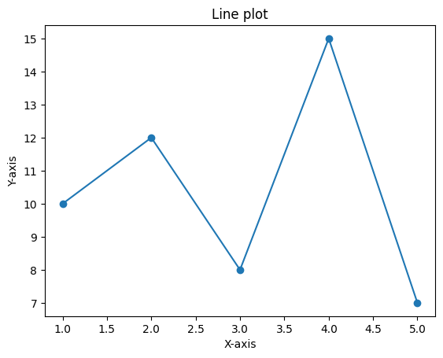
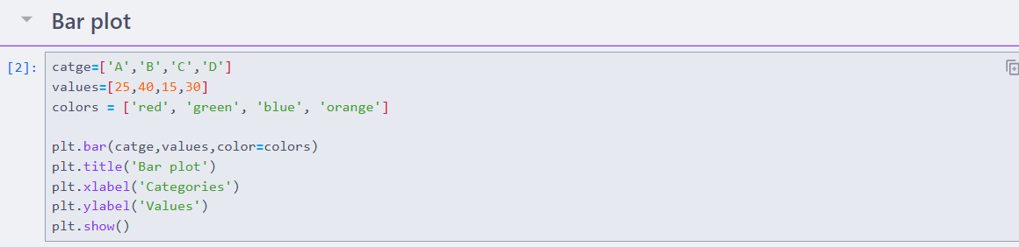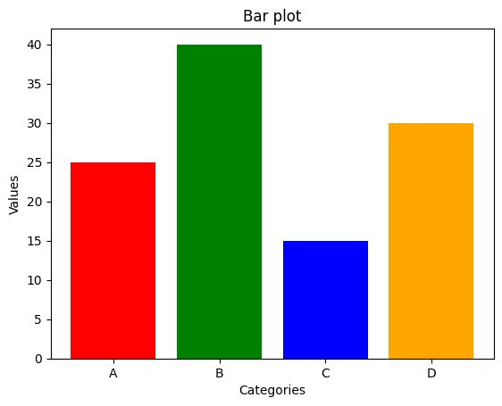
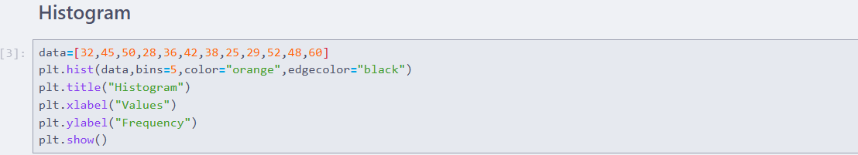
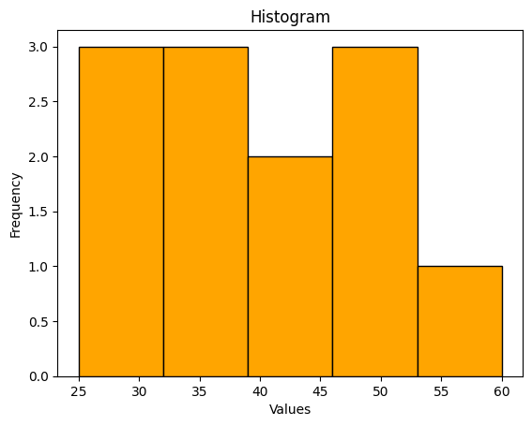
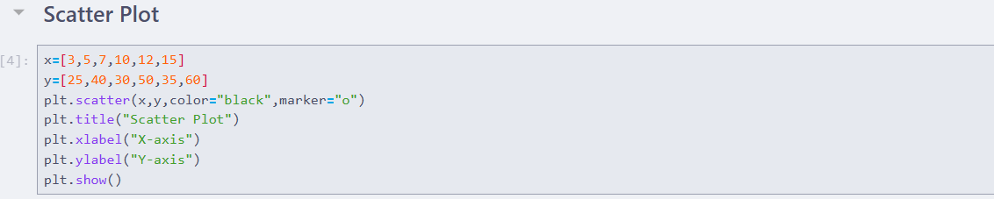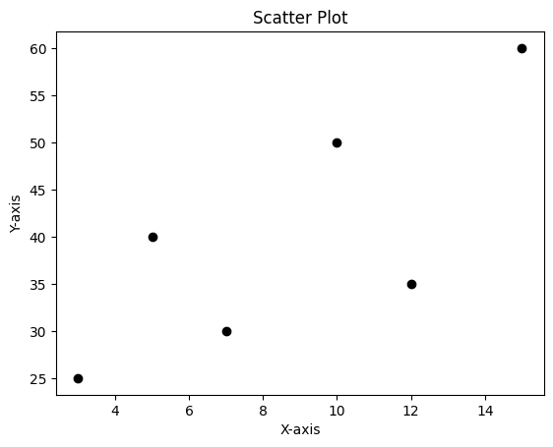
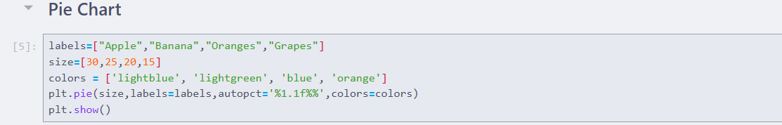
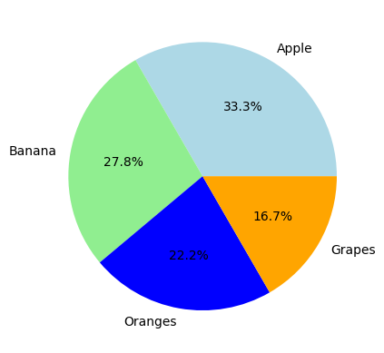
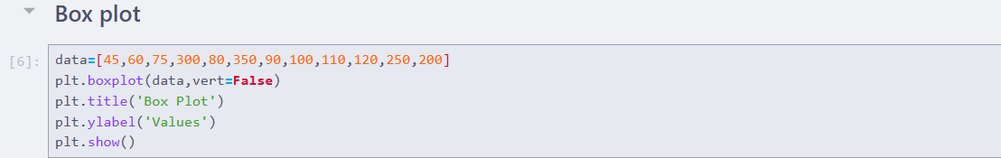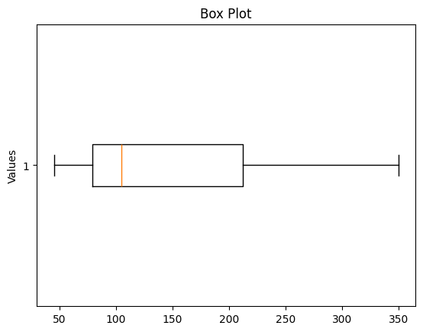
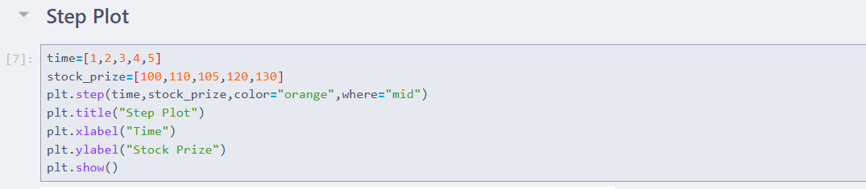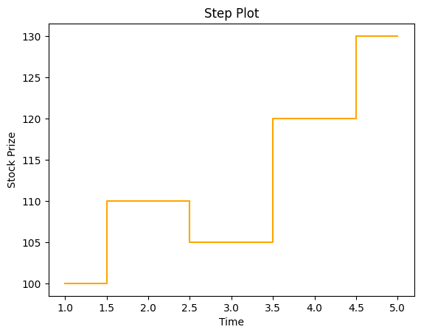

Practical 3: Implement Statistical Distribution
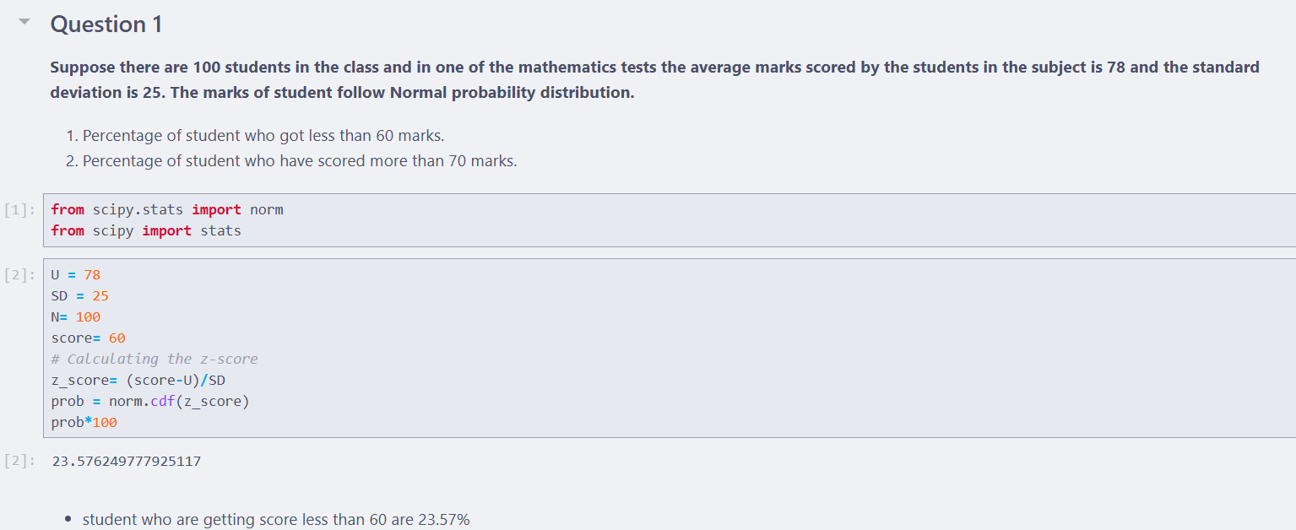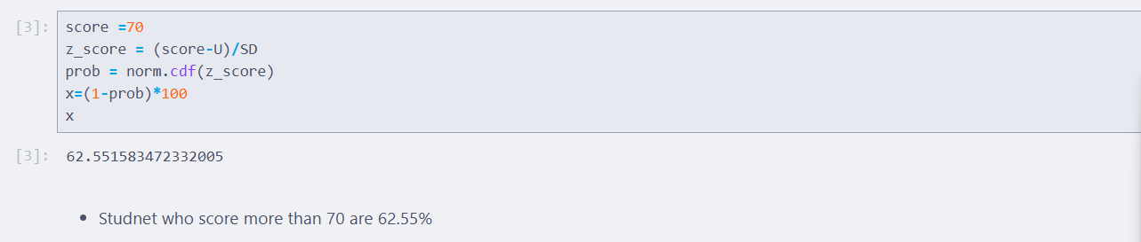
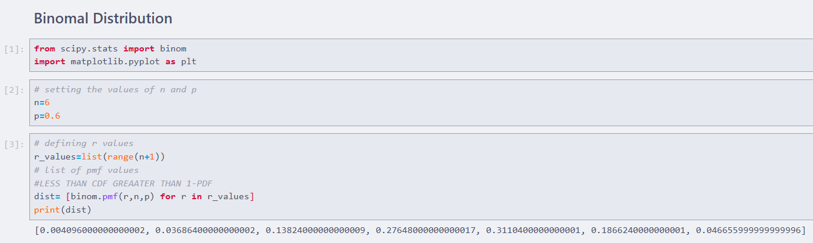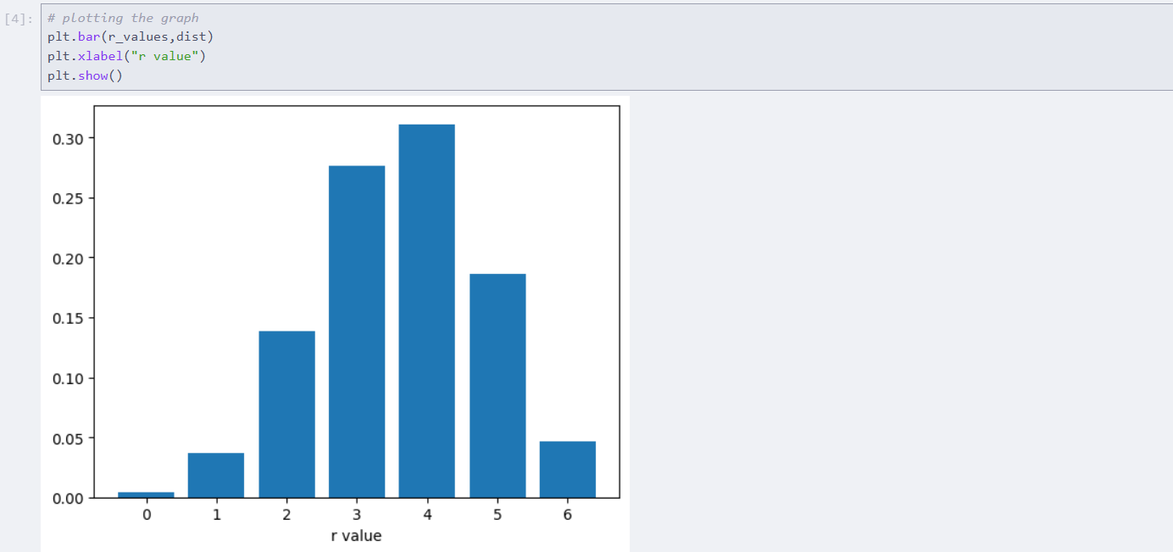
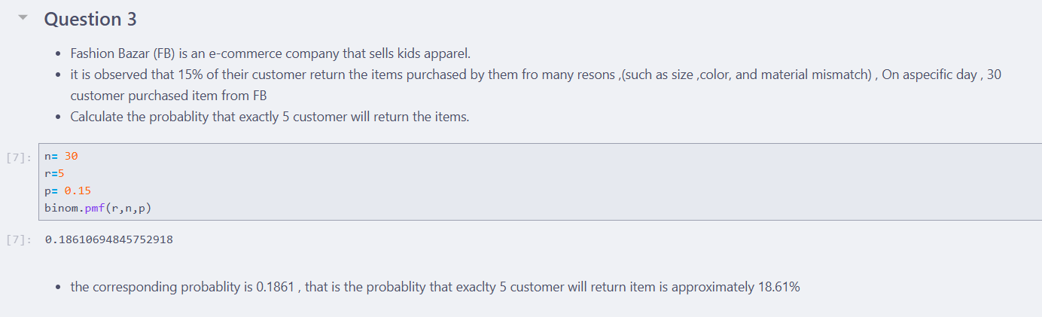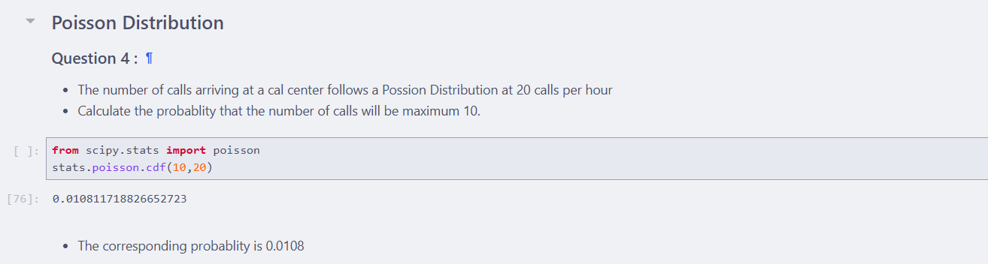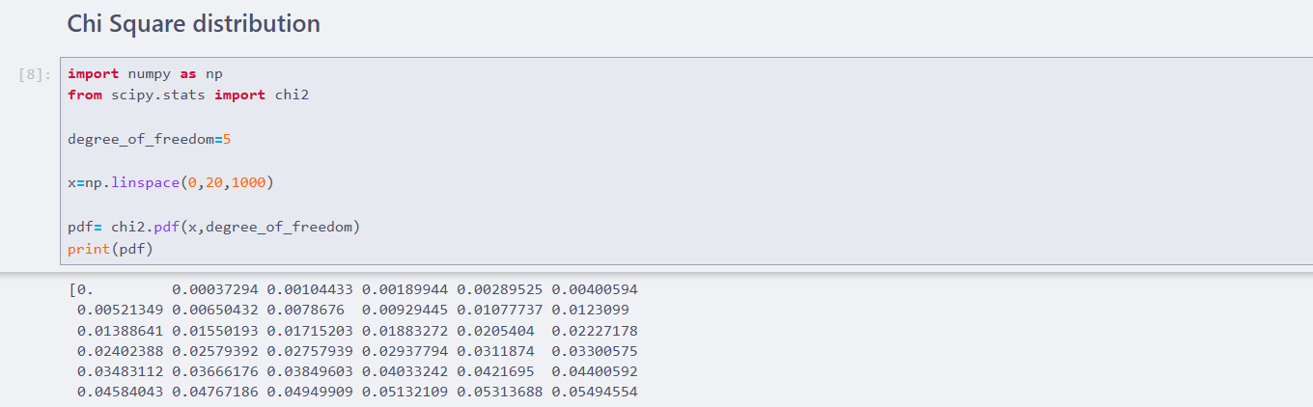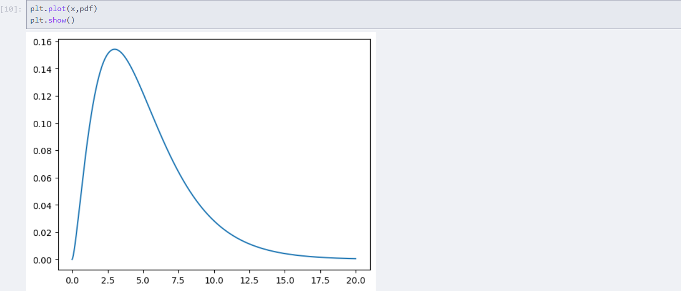

Practical 4: Implementation Hypothesis Testing
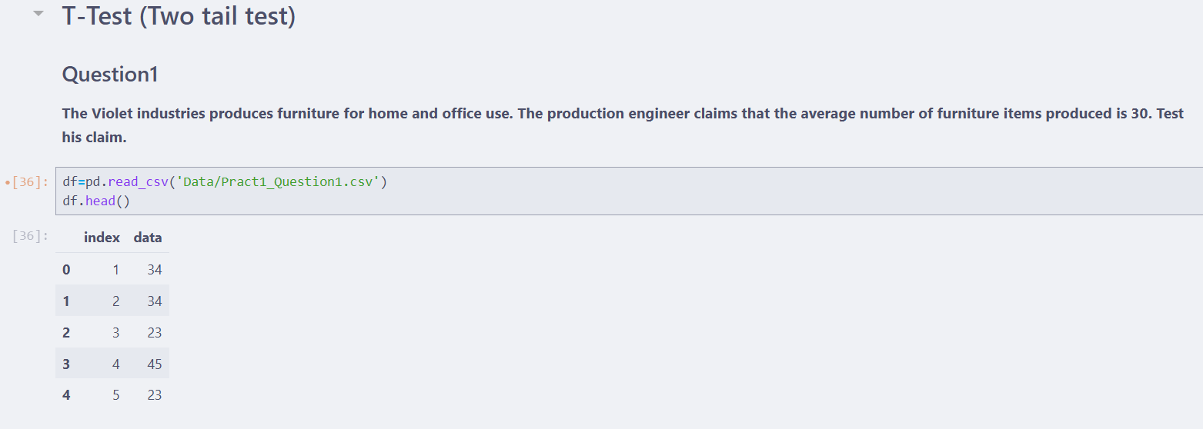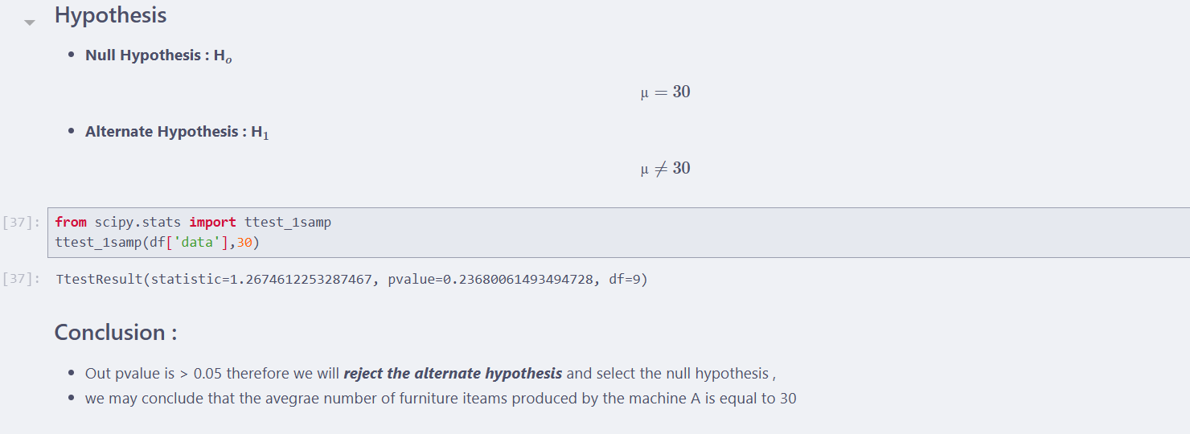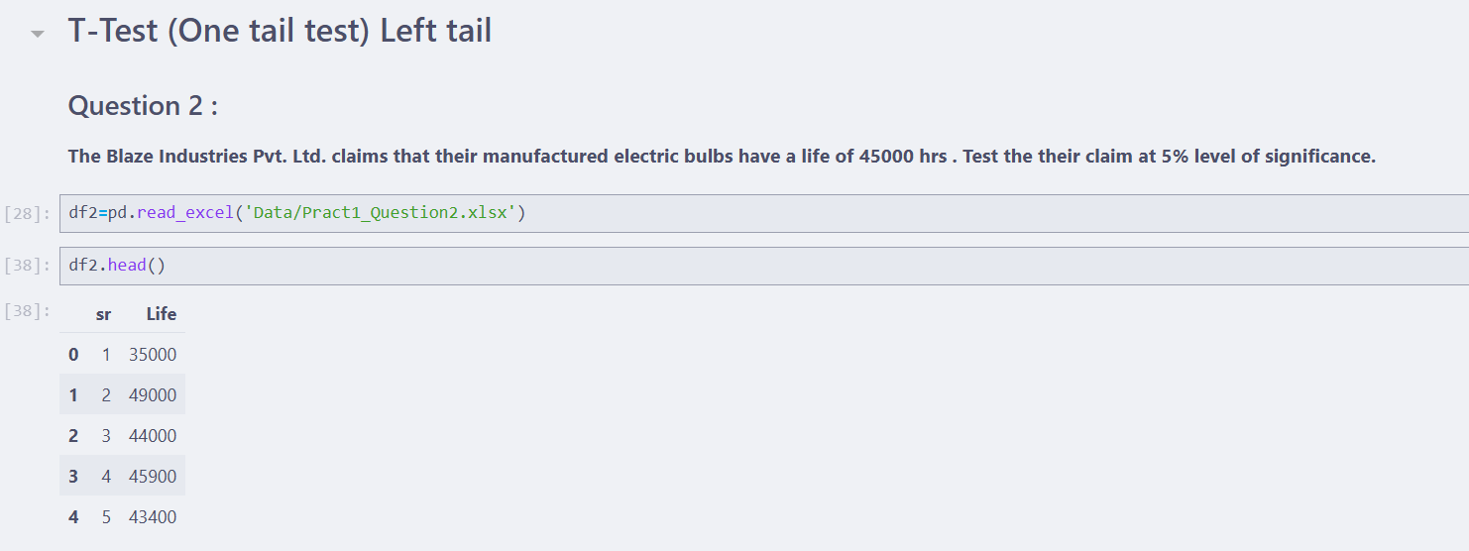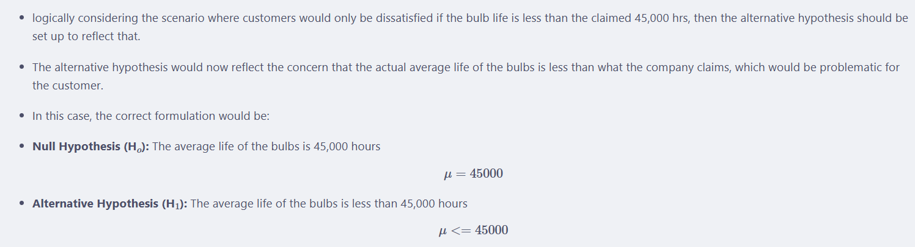
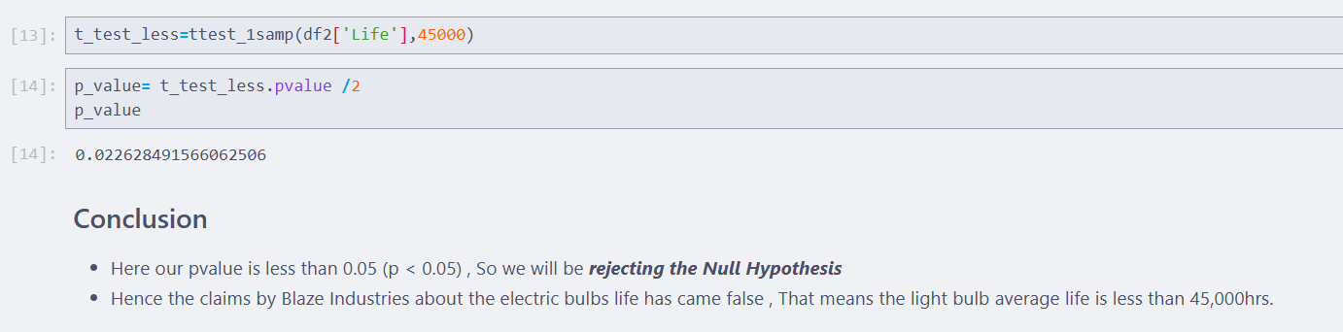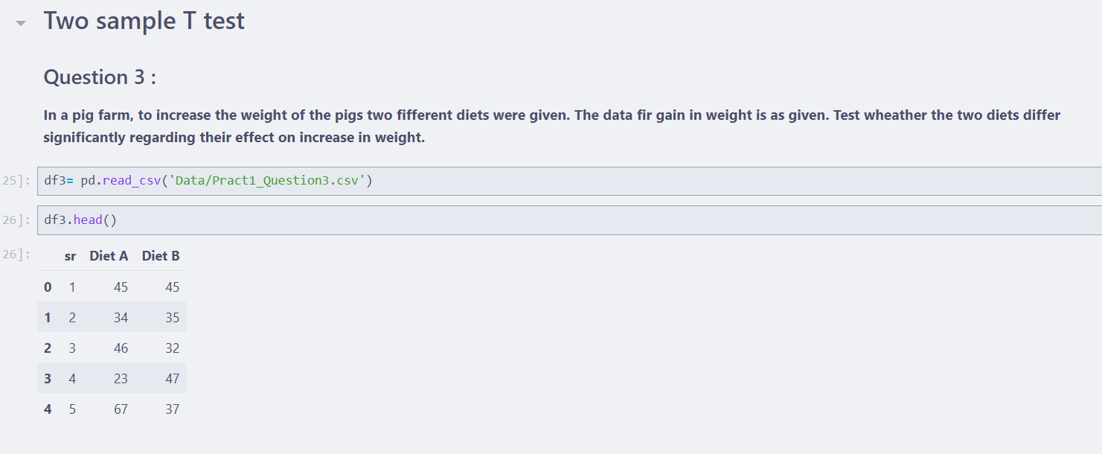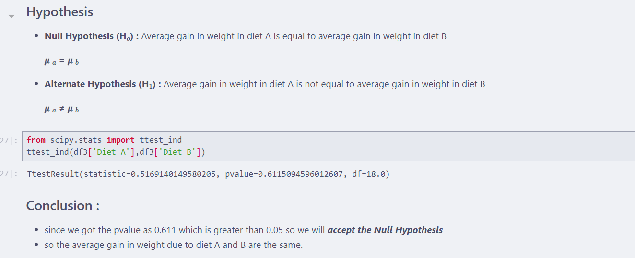
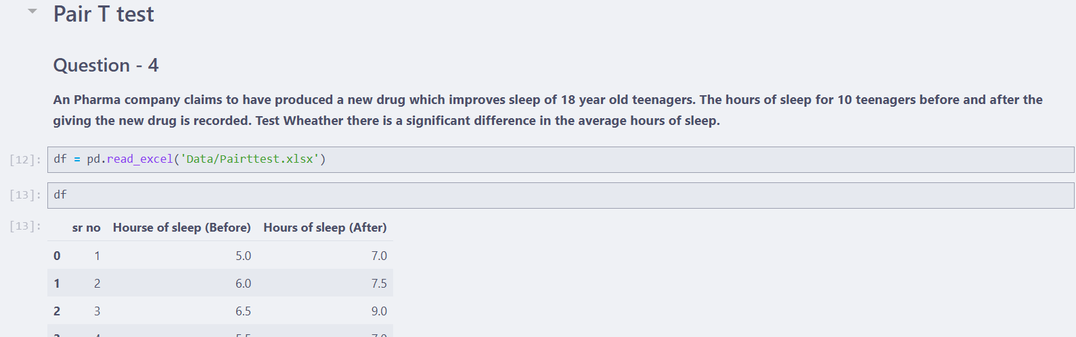
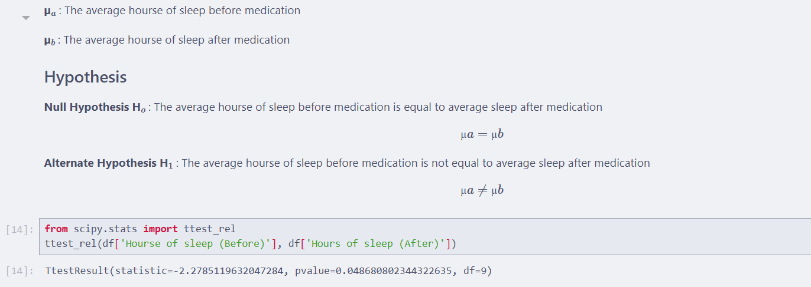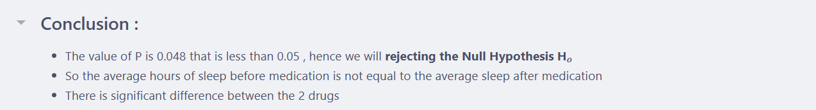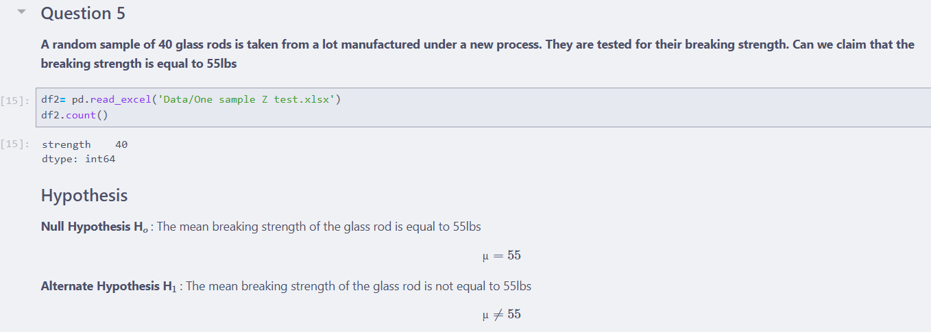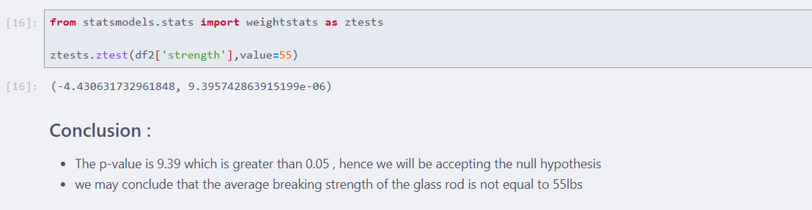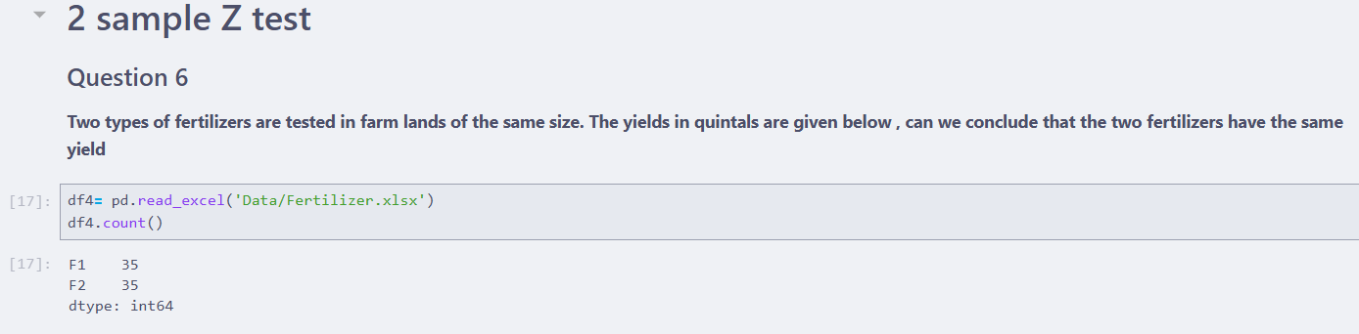
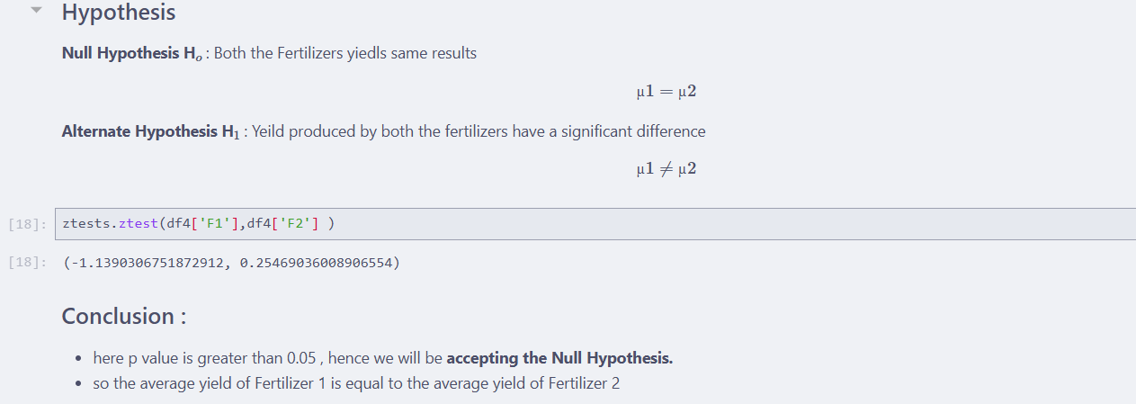

Practical 5: Perform for Exploring Categorical and Binary Data
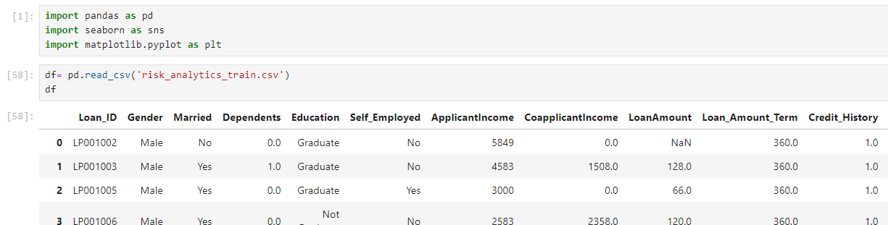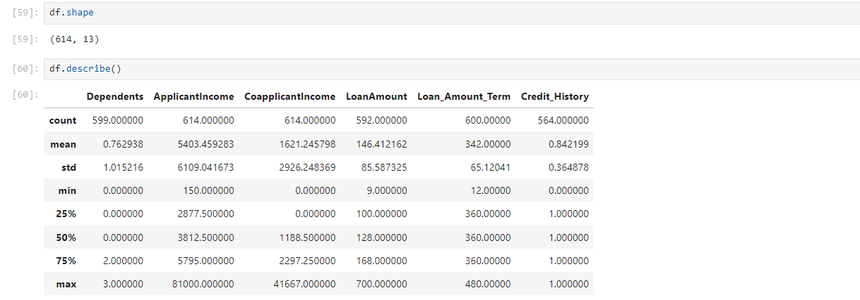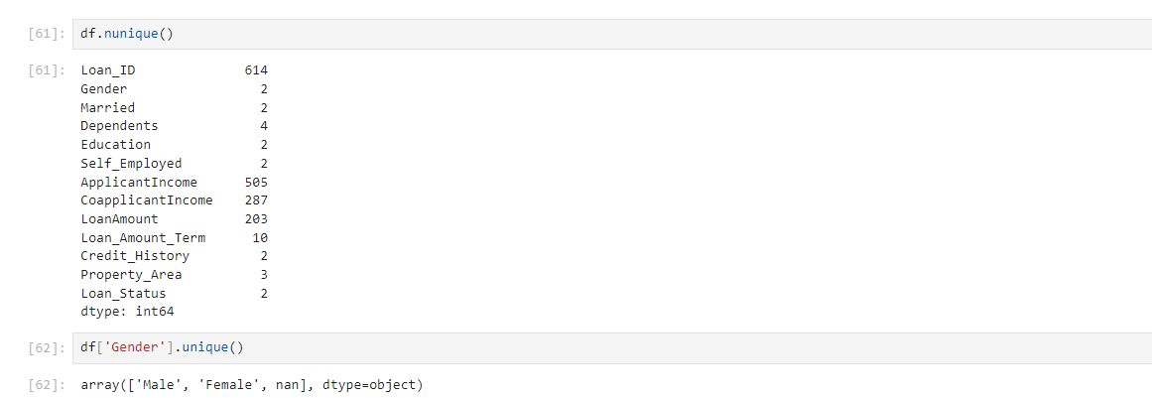
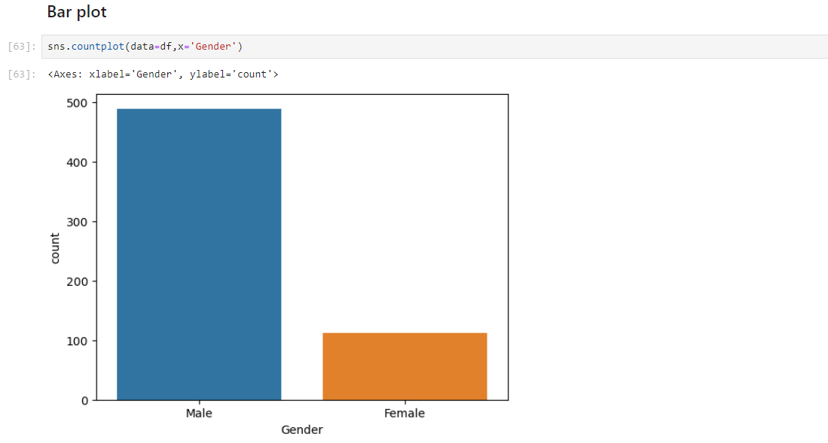
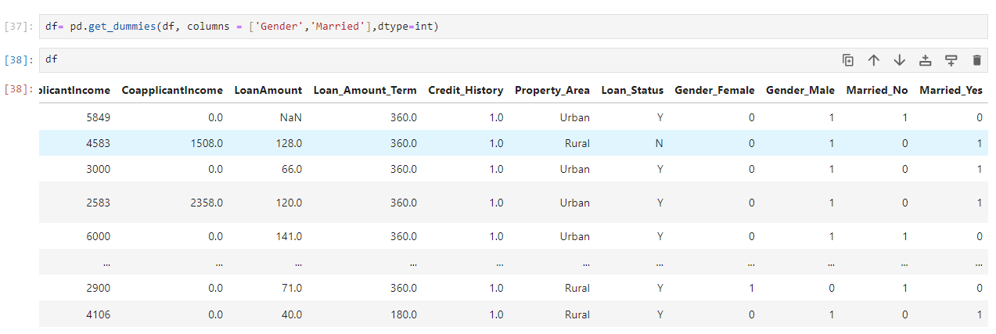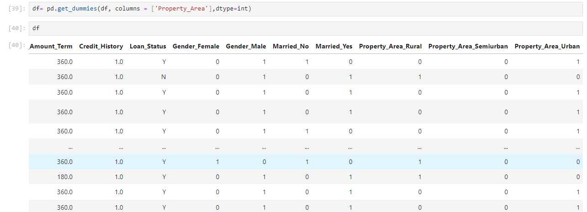
Practical 6:
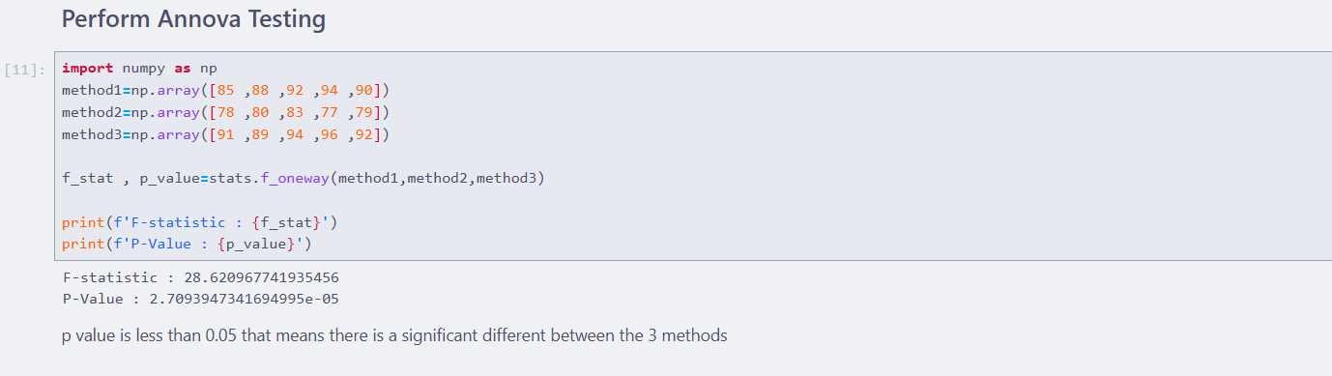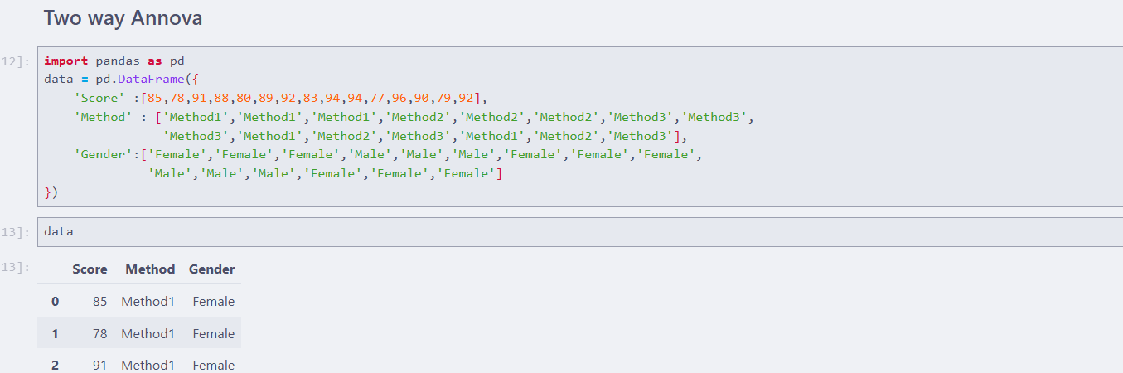
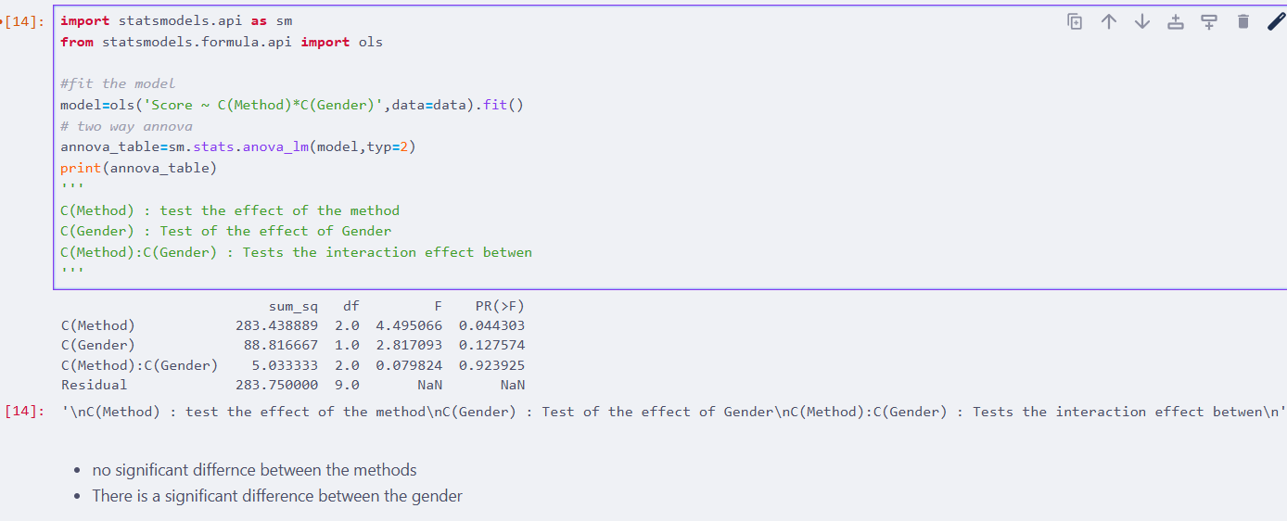

Practical 7: Implementation of Regression Analysis
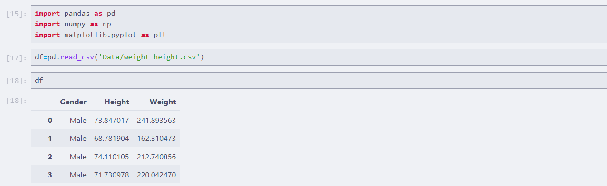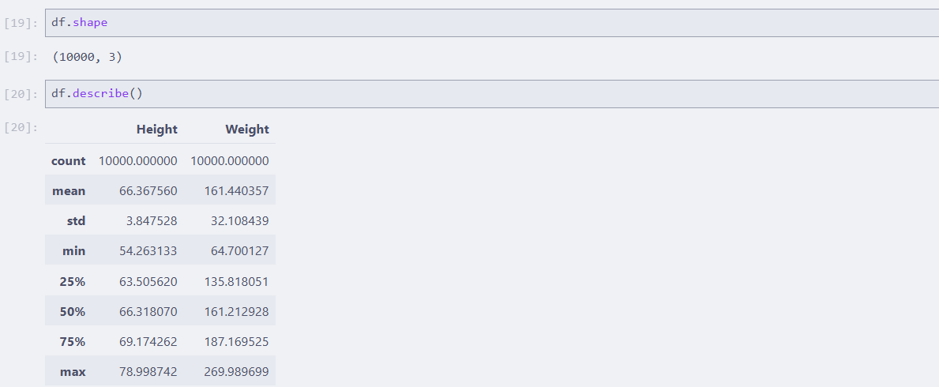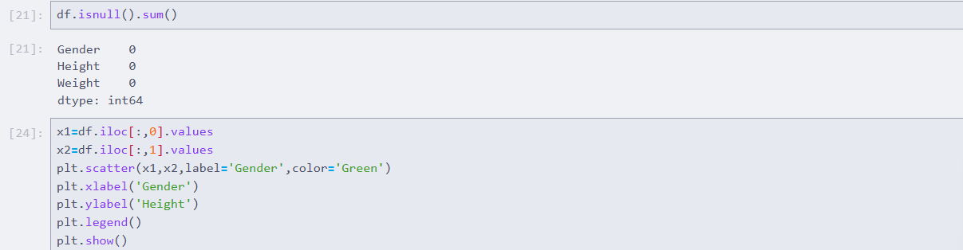
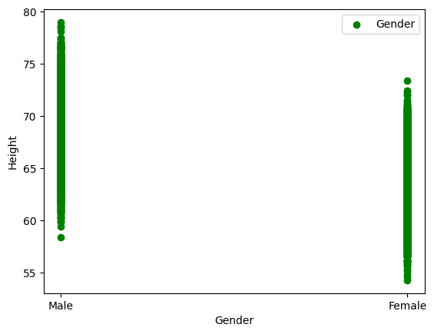
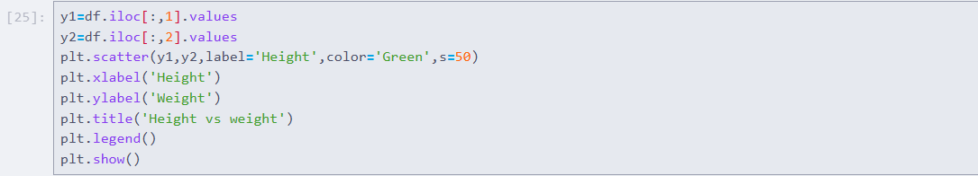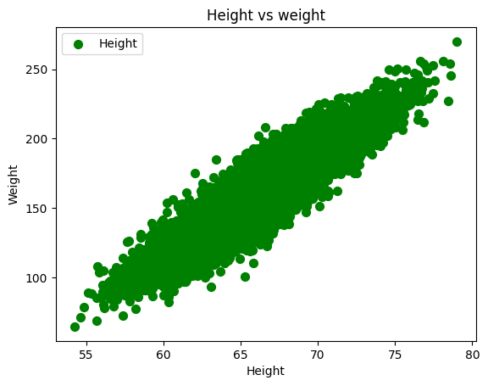
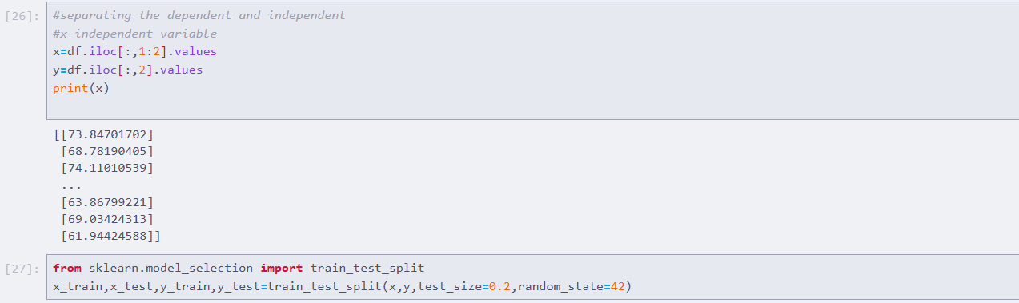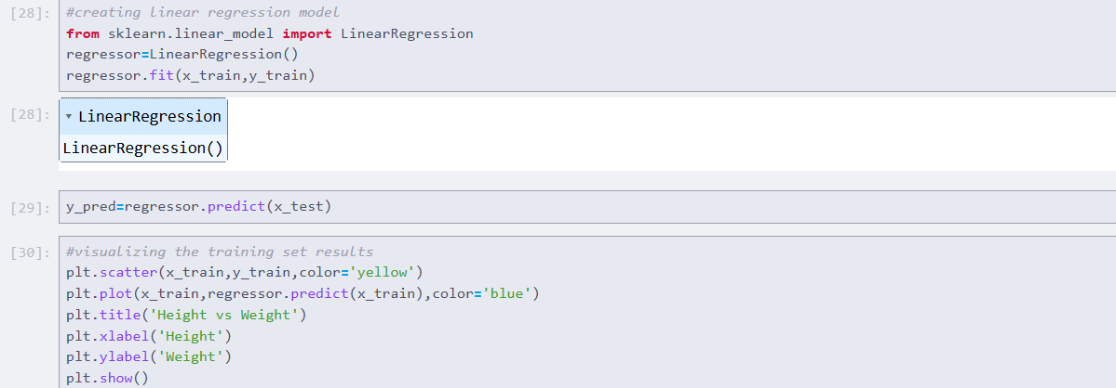
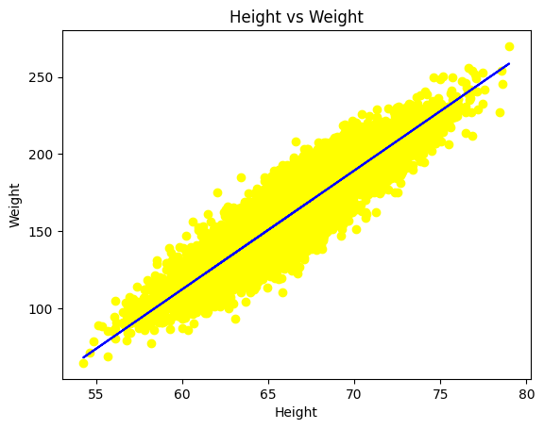
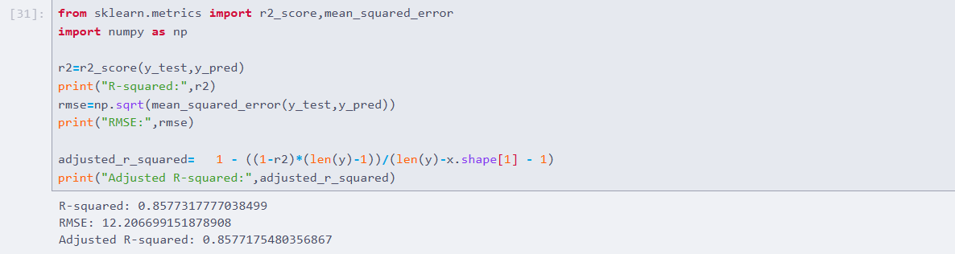

Practical 8: Perform Time Series Analysis
